**Runtime Terror:**

**Luke Williams**

**Taylor Hall**

**Kameron Jordan**

**CIS 4595: Capstone Project**

**User’s Manual**

**Accessing the Web Content:**

To access the application, enter the url http://localhost:3000/ after running the scripts to start the server and the React application. The user will then be taken to the **Login** page to enter their information for logging into the application if they already have an account. If the user tries to access any other page other than the **Login** page or **Register** page they will be redirected to the **Login**.

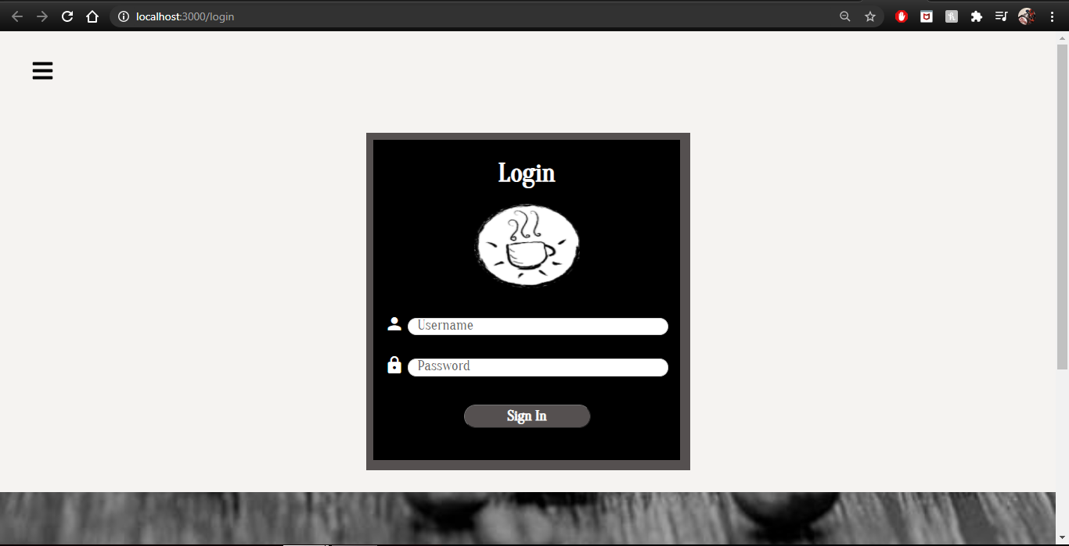

If the user doesn’t have an account already, they can create a new account via the **Register** page.

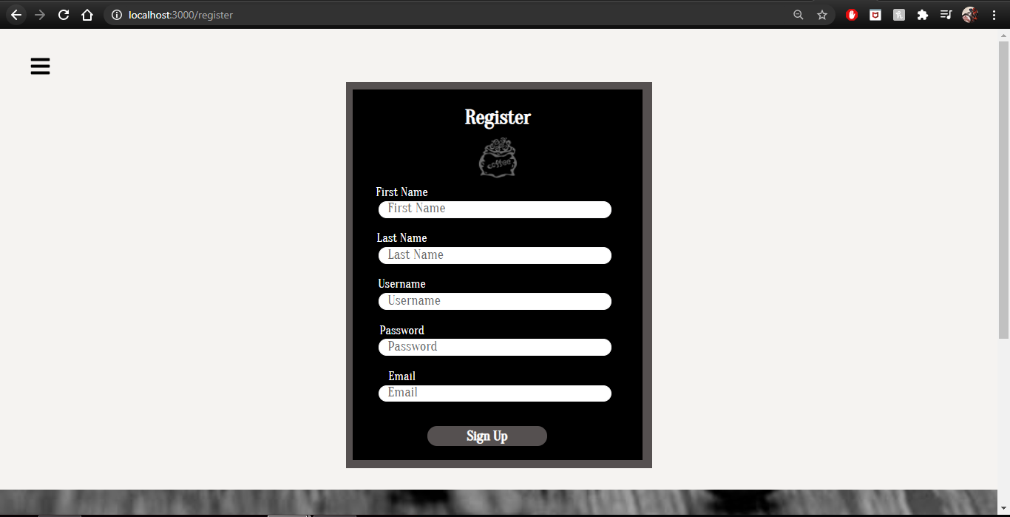

**Sending Friend Requests**

After entering the **Search** page, either by the navigation bar or clicking the search button on the **Home** page, the user will be able search for other registered users by either their username or email address. Partial matches will also work for the search. Afterwards, a list of users with matching usernames or emails will be displayed in a list.

If the user in the list is not a friend, a plus icon will appear next to their name. Clicking this icon will send a friend request to that user. If the user in the list is already a friend, then a chat icon will appear instead, and clicking on that will start a private chat with that user.

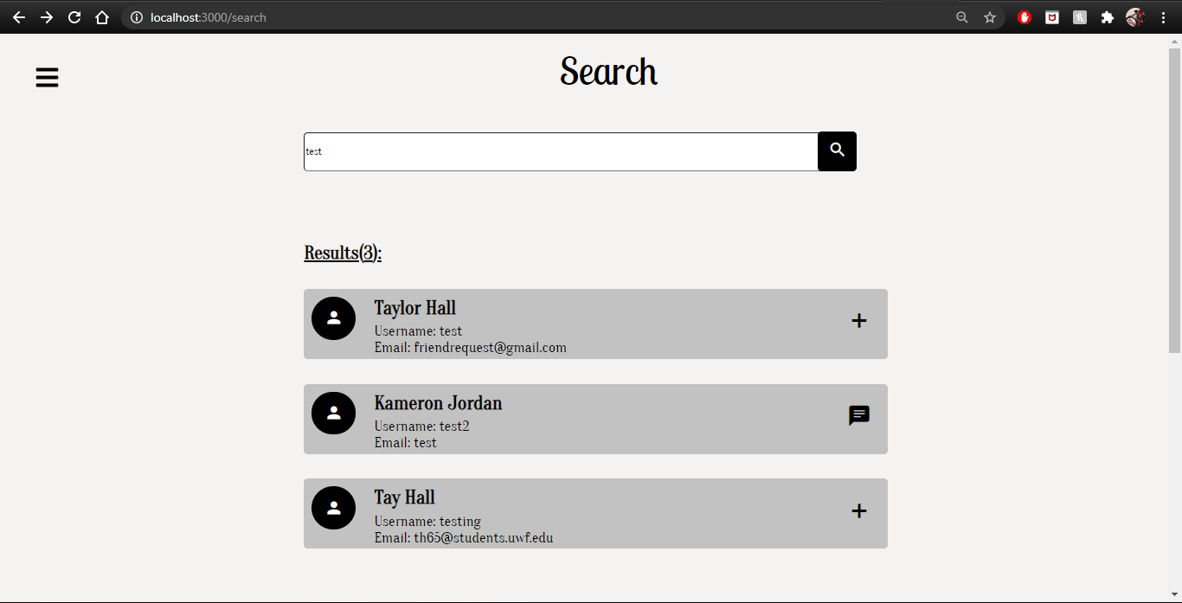

For the user who received the request, they would have to go to their **Profile** page and accept or deny the request in the **Friend Requests** tab. Accepting the request will make both users the other’s friend. Denying the request will simply remove the request from the window.

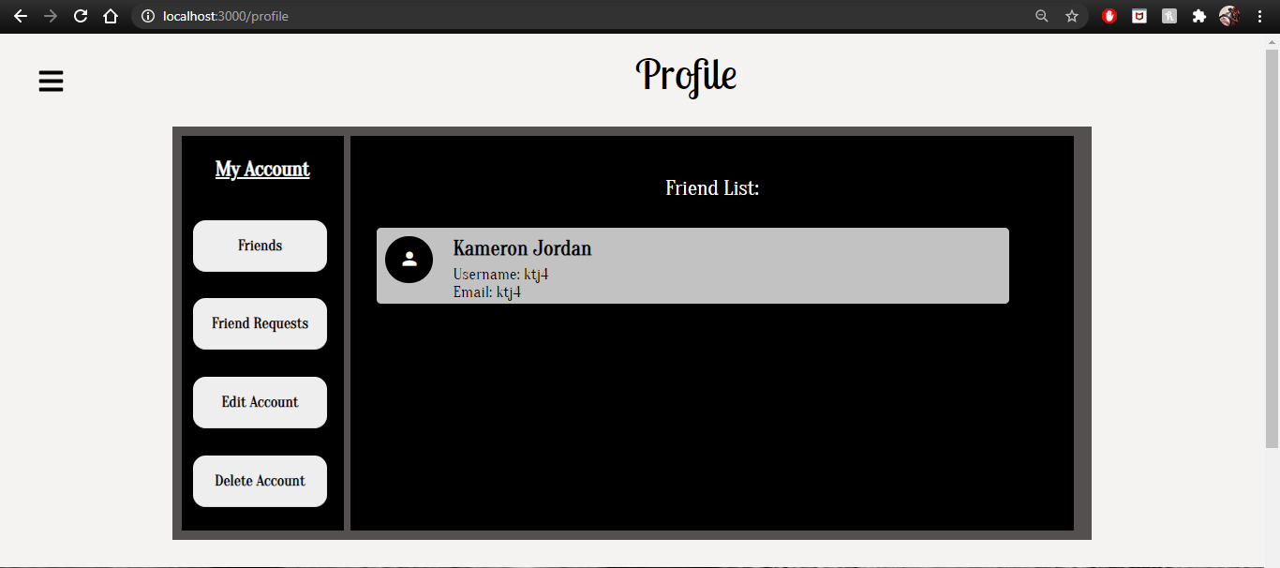

**Chatting with Other Users**

There are two types of chats: private and public. Private chats are chat rooms that will only be displayed to users who were invited into the room with its creation. Public chats are chat rooms available to any user at any time.

Users can create either type of chat via the **ChatRooms** page where they specify the room’s name, its type, and, if private, who to invite into the room. They can invite others to the room by searching for them in a text box similarly to the **Search** page.

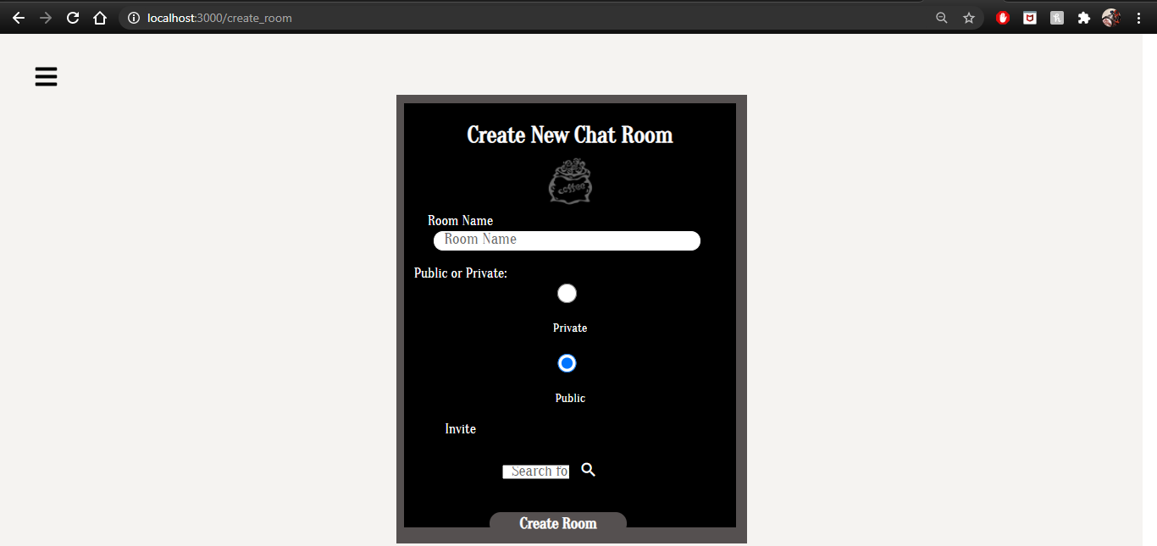

Users can join a chat room by clicking on the name of the room from the list of rooms to specify which channel to join and then click the “Join” button to actually enter the room for chatting.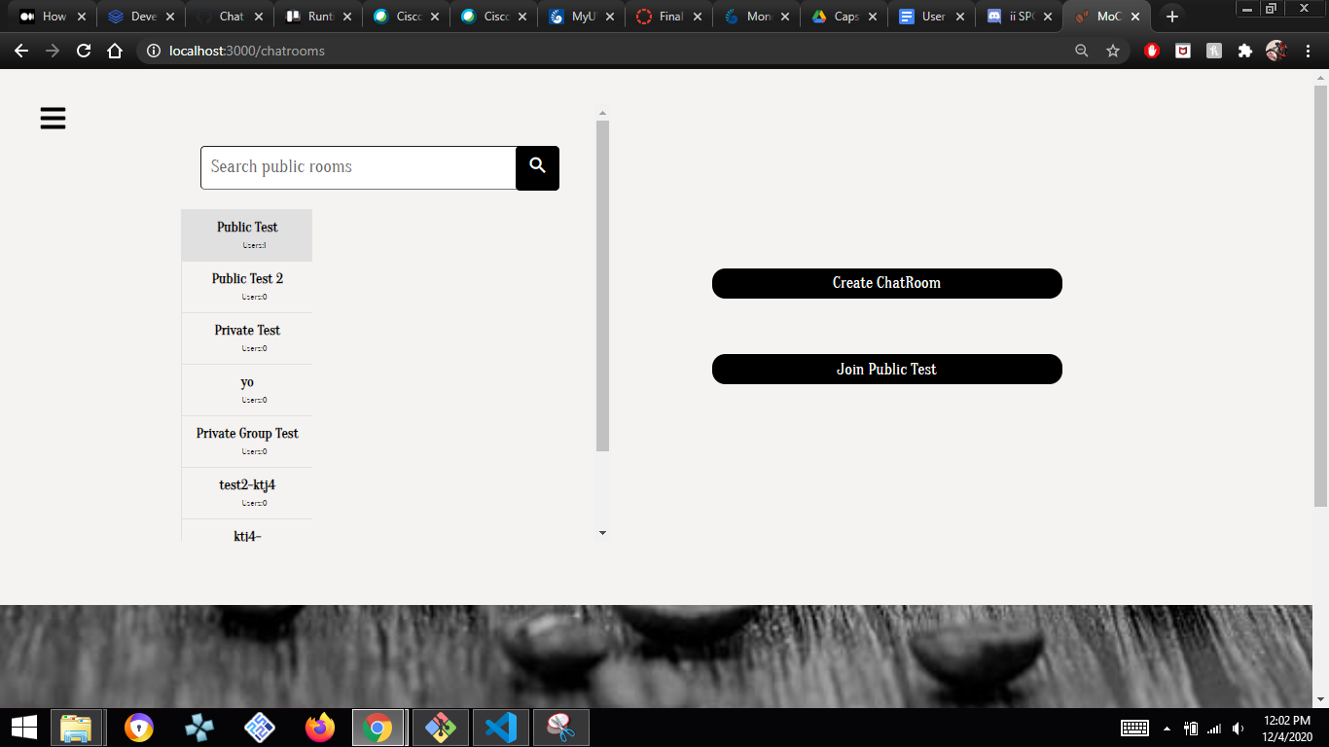

Once in a chat room, the user can send messages by typing into the textbox near the bottom of the page and clicking the “ENTER” key or the “Submit” next to the textbox. Messages sent to the user will be displayed in the window above the textbox where the user can see the message and who sent it.